1. All columns from Employee table

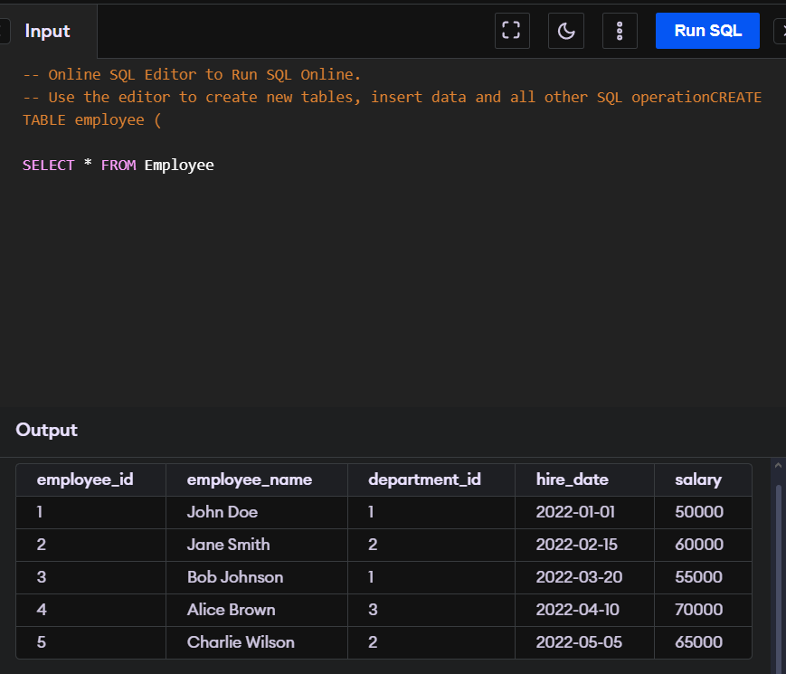

1. Departments from the department table

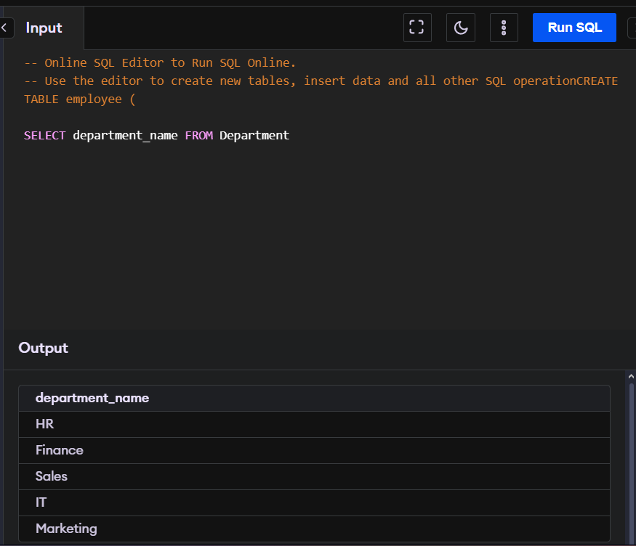

1. Employee names and salary in descending order

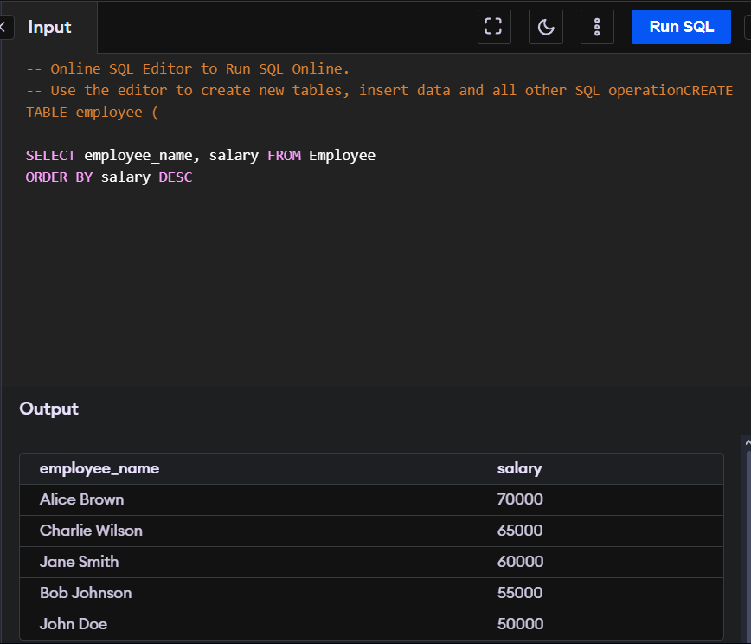

1. Product with a price between £100 and £500 in the products table

1. Orders made by employees in the 'IT' department, joining 'purchase' and 'employee' tables

1. Products with names containing 'Chair' using a wildcard

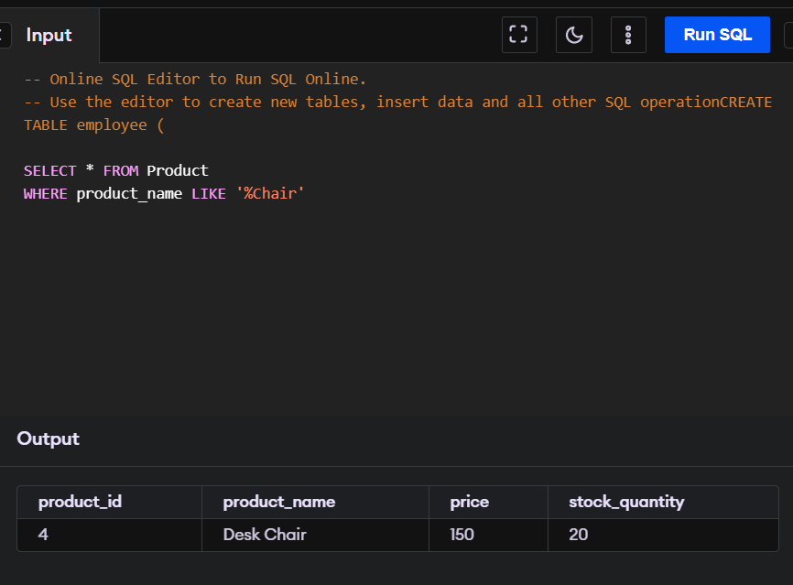

1. Orders made by employees with IDs 1, 3, and 5

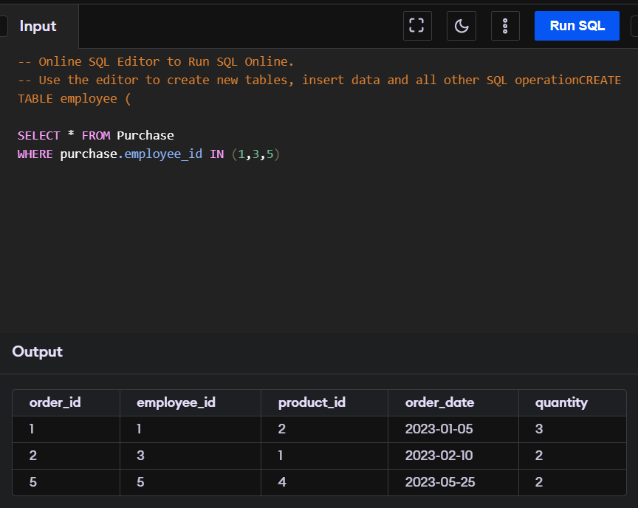

1. Average salary of all employees

1. Employees hired after '2022-03-01' with a salary greater than £60000

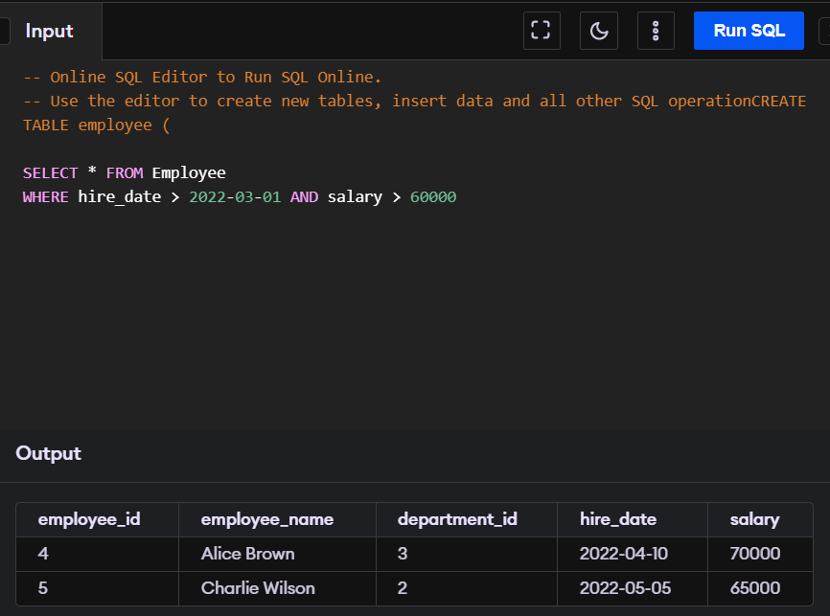

1. Departments with more than 1 employees, counting the number of employees in each department

